Name: TrustHire AI

githubUrl: https://github.com/sarvasuddisreevalli/TrustHire_AI
Description: TRUSTHIRE AI is an AI-powered recruitment intelligence and fake job detection platform designed to create a safe, smart, and trusted job search ecosystem for recruiters, students, and job seekers. The platform helps users identify fake jobs, fraudulent internships, scam recruiters, and suspicious hiring activities using Artificial Intelligence, Machine Learning, NLP, and verification systems.
The system connects verified recruiters and genuine job seekers into one unified recruitment ecosystem where AI assists in job matching, recruiter verification, fake job detection, resume analysis, and intelligent hiring recommendations. TRUSTHIRE AI aims to reduce recruitment fraud, improve hiring transparency, increase job accessibility, and provide a secure digital recruitment experience.

Functional Requirements
Authentication & User Management
• User registration and login functionality
• Role-based authentication system for recruiters and users
• Secure password encryption and session management
• User profile management system
• Recruiter account verification system
Recruiter Verification System
• Recruiter company registration
• AI-based company verification
• Email domain and website validation
• Verification badge approval system
• Detection of suspicious recruiter activities
• Recruiter trust score generation

AI Fake Job Detection
• Detect fake jobs and internship scams
• Analyze suspicious job descriptions
• Verify company website legitimacy
• Detect unrealistic salary offers
• Identify spam or phishing recruitment posts
• Generate fake job probability score
• Real-time scam alert notifications
AI Resume Analysis
• Resume upload support (PDF/DOCX)
• Extract skills, education, and experience using AI
• NLP-based resume parsing
• Smart candidate profiling system
• Resume keyword analysis
AI Job Recommendation System
• Match users with suitable jobs
• Skill-based job recommendations
• AI-powered job ranking system
• Personalized job suggestions
• Match score generation between resume and job requirements
AI Matching Algorithm
• Compare candidate skills with recruiter requirements
• Intelligent profile-job compatibility analysis
• AI-powered recommendation engine
• Improve recruiter hiring efficiency
• Increase candidate-job matching accuracy
AI Chatbot Assistance
• AI-powered recruitment chatbot
• Answer job and recruitment-related queries
• Detect fake jobs through chatbot interaction
• Provide interview preparation guidance
• Support multilingual conversations
Job & Application Management
• Recruiters can post and manage jobs
• Users can apply for jobs
• Track application status
• Manage recruiter applications dashboard
• Save and bookmark jobs
Reports & Analytics
• Fake job detection analytics
• Recruiter verification reports
• Job application analytics
• User engagement reports
• AI recommendation insights
• Export reports as PDF or CSV

Non-Functional Requirements
• Responsive web application for desktop and mobile devices
• Page load under 3 seconds
• Real-time dashboard updates
• Secure HTTPS/TLS communication
• Scalable cloud-ready architecture
• User-friendly recruitment-focused interface
• Secure authentication and encrypted data storage
• High availability and reliability
• AI response optimization for fast recommendations
• Accessibility support for all users

problem_statement: Job seekers frequently face problems such as fake job postings, internship scams, phishing recruitment links, fraudulent recruiters, and lack of transparency in hiring processes. Traditional recruitment platforms often fail to verify recruiters effectively and lack AI-driven systems to identify suspicious job activities.
Existing systems also provide limited personalized job recommendations and poor skill-job matching accuracy, making the recruitment process inefficient and unsafe for users.

proposed_solution: TRUSTHIRE AI provides a centralized AI-driven recruitment intelligence platform that integrates recruiter verification, fake job detection, AI-powered resume analysis, intelligent job matching, and chatbot assistance into one secure ecosystem.
The platform uses Artificial Intelligence, NLP, Machine Learning, and verification systems to detect fraudulent jobs, verify recruiters, recommend suitable jobs, improve hiring transparency, and ensure a safe and trusted recruitment experience for users.

technologies_used:
Frontend
• React.js
• Tailwind CSS
• Chart.js / Recharts
• Responsive UI Components

Backend
• Node.js
• Express.js
Database
• Firebase
• PostgreSQL
Artificial Intelligence
• Ollama
• Llama 3
• spaCy
• Transformers
• TensorFlow
• PyTorch
• Scikit-learn
NLP & Resume Processing
• Resume Parsing Models
• Natural Language Processing (NLP)
• OCR-based document analysis
AI Fraud Detection
• Machine Learning Classification Models
• Fake Job Detection Algorithms
• Trust Score Analysis Models
APIs & Integrations
• Email Verification APIs
• Website Validation APIs
• Authentication Services

system_architecture: TRUSTHIRE AI follows a modular multi-tier architecture where the React frontend communicates with a Node.js and Express backend through REST APIs. The backend integrates AI modules, NLP processing systems, recruiter verification services, job recommendation engines, and fake job detection models.
Firebase/PostgreSQL stores user profiles, recruiter data, resumes, job postings, verification results, and analytics information. AI modules analyze resumes, verify recruiters, detect fraudulent jobs, and generate intelligent recommendations while the chatbot system provides interactive recruitment assistance.

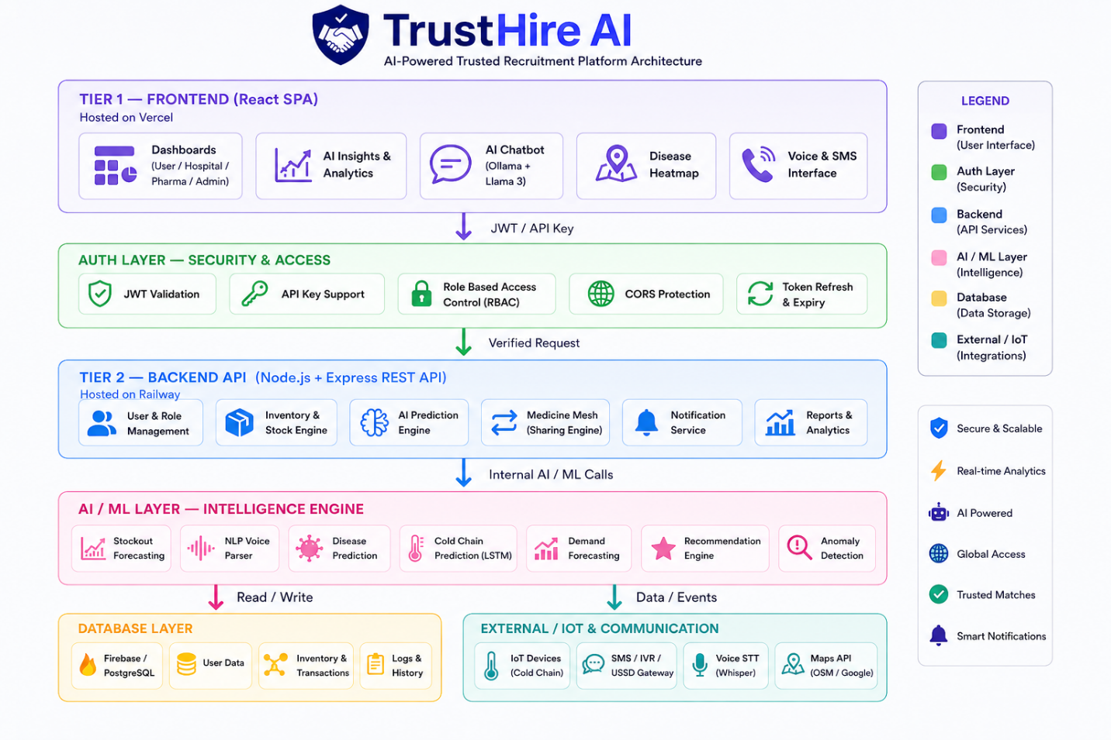

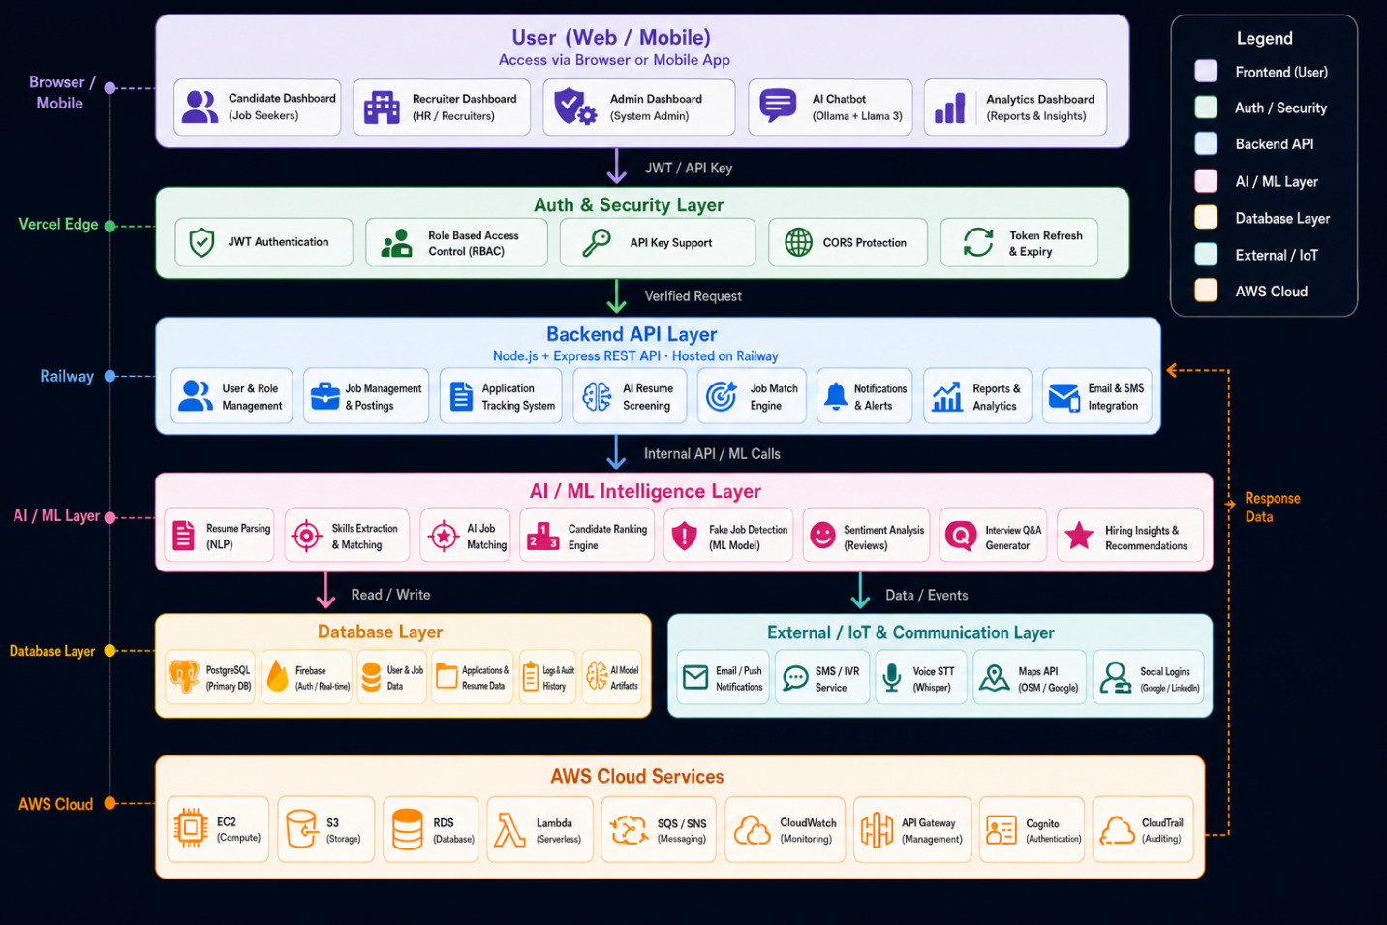

in_scope:
• Recruiter verification system
• Fake job and internship detection
• AI-powered resume analysis
• Smart job recommendation engine
• AI chatbot integration
• Resume and skill extraction
• Job application management
• Recruiter trust scoring
• Real-time recruitment analytics
• AI matching algorithm
• User and recruiter dashboards

out_scope:
• Real-time government employment integration
• Advanced biometric authentication
• Physical document verification systems
• Nationwide recruitment authority integration
• Payroll and salary processing
• Video interview monitoring systems
• Blockchain-based recruitment tracking
future_enhancements:
Phase 1
• Mobile application development
• Advanced multilingual chatbot support
• AI-based interview preparation assistant
• Smart resume builder integration
Phase 2
Blockchain-based recruiter verification
• Real-time video interview analysis
• AI-powered career guidance system
• Advanced recommendation engine
Phase 3
• Nationwide recruiter integration
• Government employment portal connectivity
• AI-driven hiring prediction system
• Global recruitment platform expansion
• AI-powered professional networking system

conclusion:
TRUSTHIRE AI is an intelligent recruitment ecosystem designed to modernize hiring operations and job security using Artificial Intelligence and real-time analytics. The platform addresses critical recruitment challenges including fake job postings, recruiter fraud, poor job matching, and lack of hiring transparency by integrating AI verification, fake job detection, resume analysis, and intelligent job recommendations into one unified solution.
TRUSTHIRE AI demonstrates how AI and digital recruitment technologies can transform traditional hiring systems into proactive, intelligent, and trusted recruitment ecosystems that improve hiring efficiency, protect job seekers, and create safer employment opportunities for everyone.

projectType: AI-Powered Trusted Recruitment and Fake Job Detection Platform

